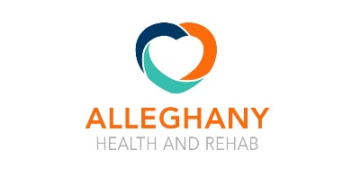
Alleghany Health & Rehab
http://alleghanyrehab.com/
540-862-5791
https://www.carilionclinic.org/
800-442-8482

http://www.catawba.dbhds.virginia.gov/
540-375-4200

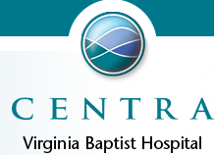
https://www.centrahealth.com/VBH
Lynchburg 434-200-3000

https://www.friendship.us/ 540-265-2110

https://theglebe.org 540-591-2105
https://www.grifolsplasma.com/en/home
540-344-3247

www.kissito.org/ 540.265.0322

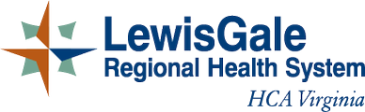
https://lewisgale.com/location/lewisgale-medical-center
540-776-4138

https://www.ourladyofthevalley.com/
540-345-5111

https://www.plannedparenthood.org/planned-parenthood-south-atlantic 276-732-1996

https://richfieldliving.com/ 540-380-4500

https://www.roanokeva.gov/835/Sheriffs-Office
540-853-5894

https://www.mfa.net/center/raleigh-court-health-rehabilitation-center
540-342-9525

https://www.mfa.net/center/salem-health-rehabilitation-center
540-345-3894

https://www.mfa.net/center/springtree-health-rehabilitation-center
540-981-2790

https://www.mfa.net/center/stanleytown-health-rehabilitation-center
276-629-1772

Salem VA Medical Center /
https://www.salem.va.gov/
540-982-2463

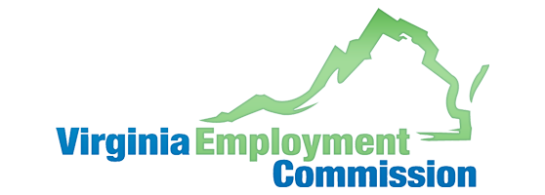
http://www.vec.virginia.gov/roanoke
(540) 613-8220

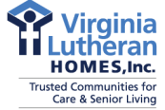
Brandon Oaks 540-776-2600
http://www.vlhnet.org/ 540-562-5443

