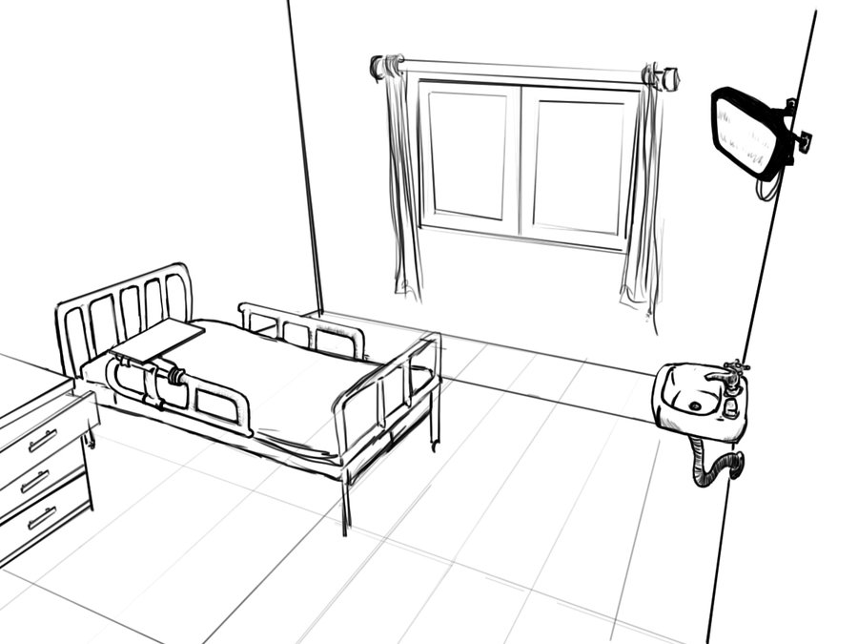
HOSPITAL
OF HORROR

[Guaranteed to send chills down the spine of any health care professional]

October 29th and October 30th
Peds/OB Suite
Submit completed assessment to enter for a chance to win a gas card and ECPI T-shirt!

