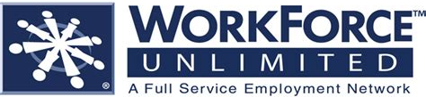
HIRING EVENT
Monday, May 21st 9am-12pm
Virginia Career Works – Roanoke Center
3601 Thirlane Road NW Suite 2
Roanoke, VA 24019
For the following positions:
JO# 1330239 Assembler
JO# 1330245 Welder (SMAW, MIG, FCAW)
JO# 1330249 Welder
JO# 1330256 Forklift Operator
JO# 1338638 Quality Assurance Technician
JO# 1338668 Maintenance Technician

Positions currently opened may be viewed at www.vaworkconnect.com
Please complete online application before coming to Hiring Event.
Please come prepared to meet employer representatives!
Full-Time, Part-Time and Weekend Shifts Available
Virginia Employment Commission is An Equal Opportunity Employer/Program.
Auxiliary aids and services are available upon request to individuals with disabilities.

